**Rubidium Bromide (RbBr)**

*Space group*: Fd-3m, 225, rocksalt

*Lattice vectors*: *R*1 = (-*a*/2, 0, *a*/2); *R*2 = (0, *a*/2, *a*/2); *R*3 = (-*a*/2, *a*/2, 0)

*Atom positions*: Rb= (0, 0, 0); Br= (*a*/2, *a*/2, *a*/2)

*Isotopes*: 72.17% 85Rb (84.912 amu); 27.83% 87Rb (86.909 amu);

50.69% 79Br (78.918 amu); 49.31% 81Br (80.916 amu)

*DFT*: Use VASP or QE. PBE PAW (**USE PLAIN PBE!!)** The QE website does not have pbesol for Rb)  
(QE: Rb.pbe-spn-kjpaw_psl.1.0.0.UPF and Br.pbe-n-kjpaw_psl.1.0.0.UPF;

VASP: standard version; Rb_sv) –

**Checklist** (*all data should be reported for the 2-atom primitive cell*)

* Please provide all computational costs in cores*hours

***Structure/electrons***

* Converged relaxed ‘temperature (T)=0’ lattice constant *a* (target accuracy < 0.005 Å)

- Single value with 4 significant figures: 7.017 Å

* Methods / convergence criteria

- Energy/force thresholds: EDIFF=1E-6 eV, EDIFFG=1E-5 eV/Å

- Integration mesh / grid shifting: k-mesh=8x8x8

- Smearing used?: ISMEAR=0 (Gaussian), SIGMA=0.03 eV

**Directly optimized by VASP with ISIF=3, test the convergence with respect to ENCUT, k-mesh, SIGMA, and EDIFF**

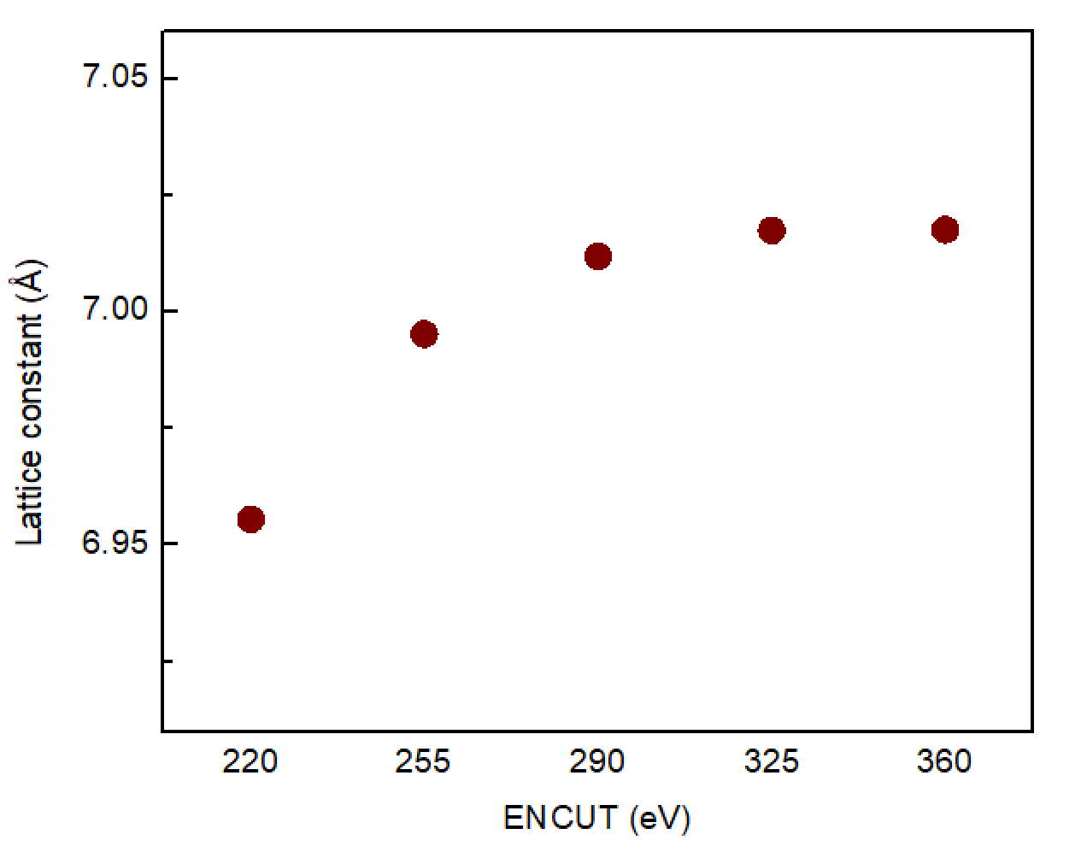

Fig 1. Lattice constant optimized with different ENCUT.

(k-mesh=8x8x8, ISMEAR=0, SIGMA=0.03eV, EDIFF=1E-6 eV)

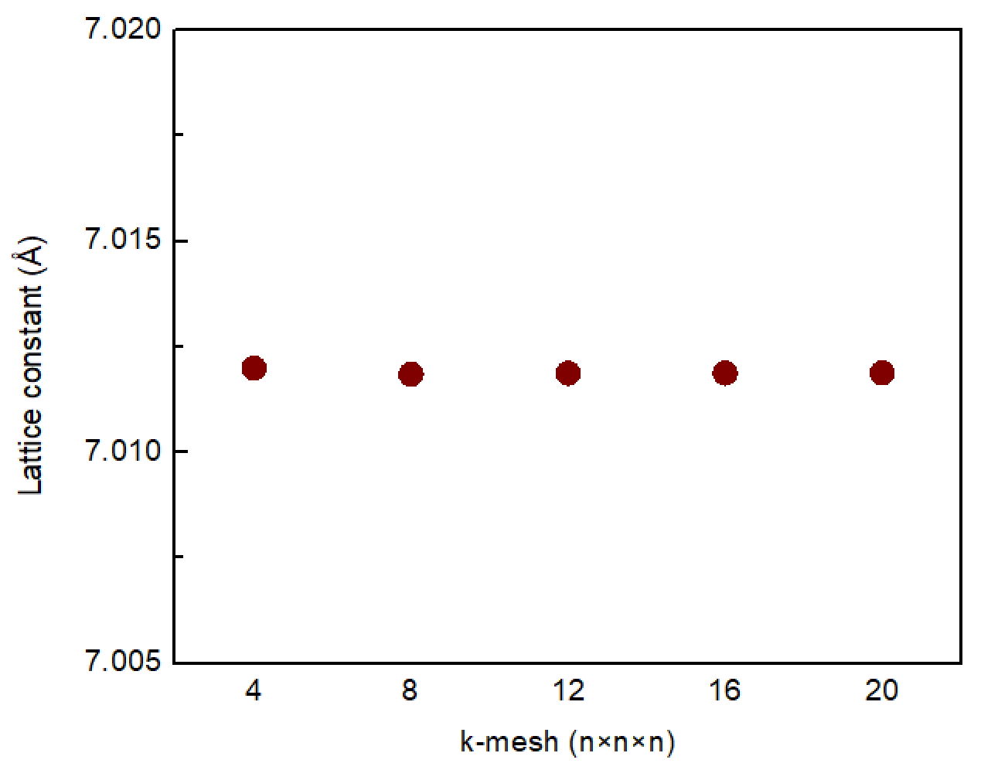

Fig 2. Lattice constant optimized with different DFT k-point grids.

(ENCUT=290eV, ISMEAR=0, SIGMA=0.03eV, EDIFF=1E-6 eV)

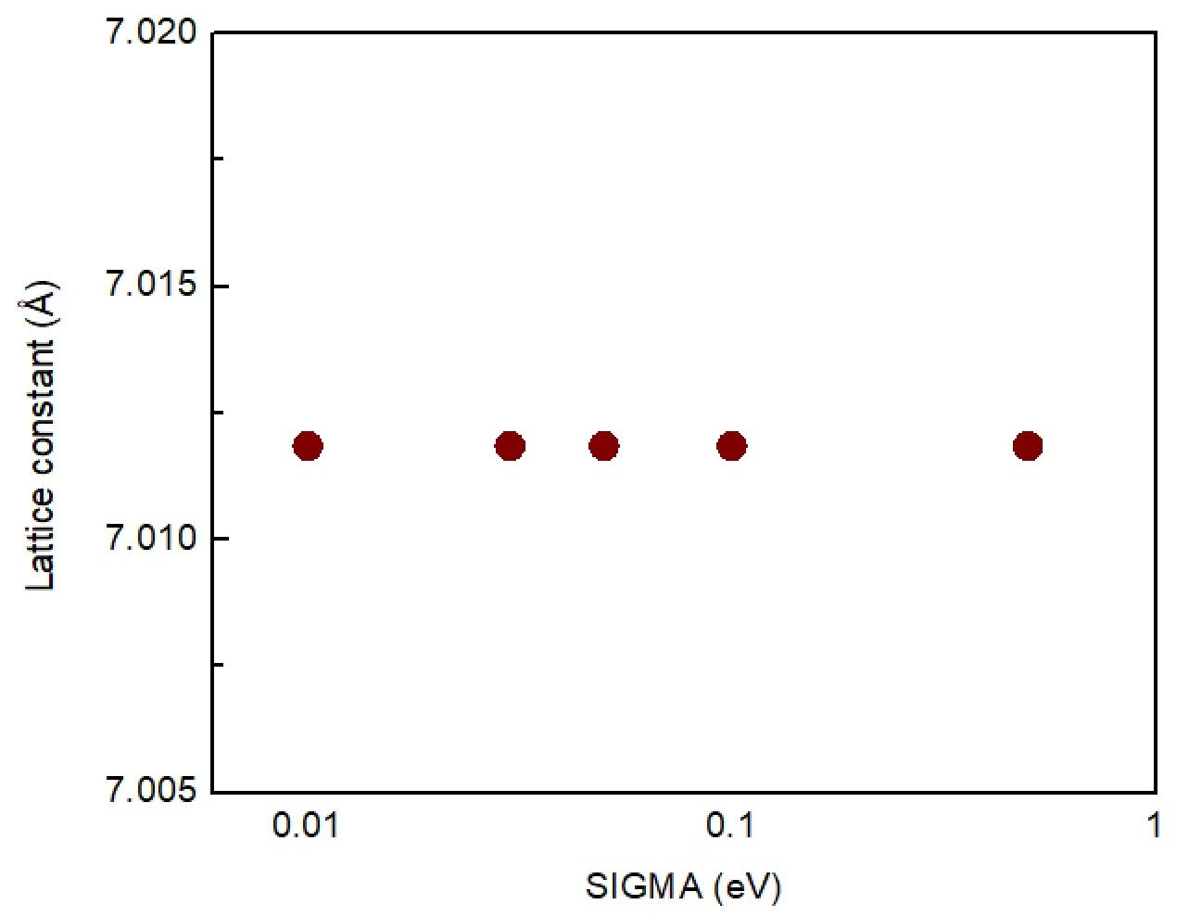

Fig 3. Lattice constant optimized with different SIGMA.

(ENCUT=290eV, k-mesh=8x8x8, ISMEAR=0, EDIFF=1E-6 eV)

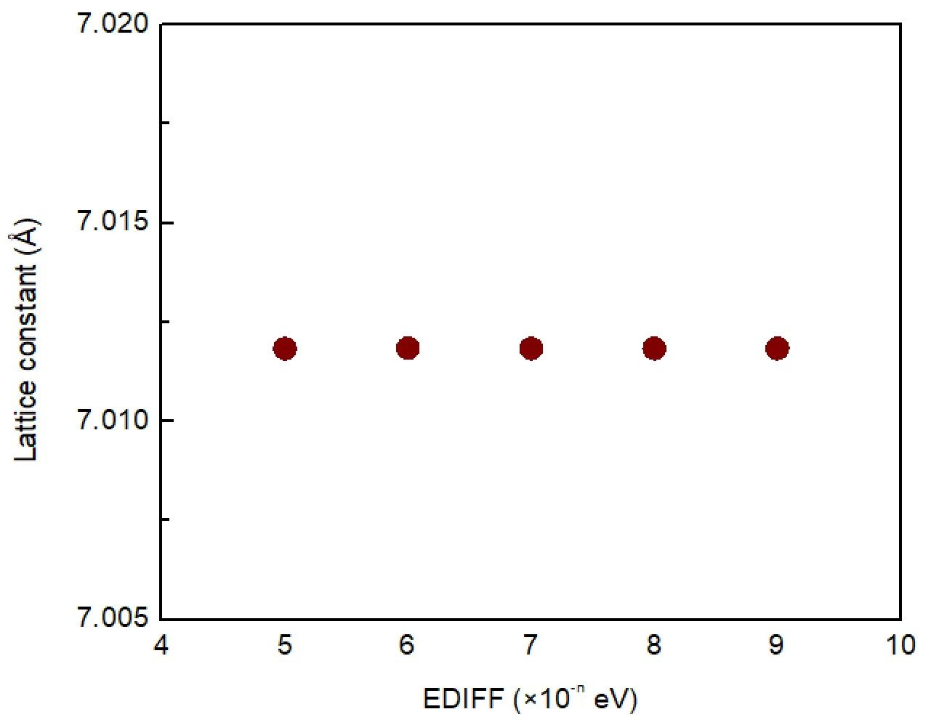

Fig 4. Lattice constant optimized with different EDIGG.

(ENCUT=290eV, k-mesh=8xx8, ISMEAR=0, SIGMA=0.03 eV)

**Based on the above tests, the structure optimization was performed with ENCUT=325 eV, k-mesh=8x8x8, ISMEAR=0, SIGMA=0.03 eV, and EDIFF=1E-6 eV.**

* Other notes / cpu hours (*e.g., multiple relaxations, compilers, hardware*)

hardware: Intel Xeon Gold 6150, 18 core/CPU, 2 CPUs/node

Cpu hours: 0.089 cores*hours

* All input files to run fully converged calculations (*e.g., qe.scf.in, POSCAR*)

Input files: POSCAR, INCAR, POTCAR, KPOINTS, run.sh

Location: Team Shiomi/RbBr/Han Meng_VASP/01_Structure/Input files

* Converged electron band dispersion (target accuracy < 0.1 eV for Γ/X/L frequencies)

- Numerical data: normalized wavevectors (q) and band energies (E): top 3 valence bands and 5 conduction bands (excel file, text file, or google sheet)

- q in units of 2π/*a* and f in eV

- 3 segments: Γ→X, Γ→K→X, and Γ→L evenly divided with ~100 q points per segment

- 3 files, one for each segment. For each scaled q from 0 to 1 list (~100 rows): q, E1, E2, E3, E4, E5, E6, E7, E8

File name: G-X.txt, G-K-X.txt, G-L.txt

Location: Team Shiomi/RbBr/Han Meng_VASP/02_Electrons/Results

* Methods / convergence criteria

- Energy/force thresholds: EDIFF=1E-9 eV, none for force

- Integration mesh / grid shifting: k-mesh=8x8x8

- Fermi band shift: Yes, Fermi level= -1.953332 eV

- Smearing used?: ISMEAR=0 (Gaussian), SIGMA=0.01 eV

* Evidence of converged band structure

- Band structure with varying integration meshes

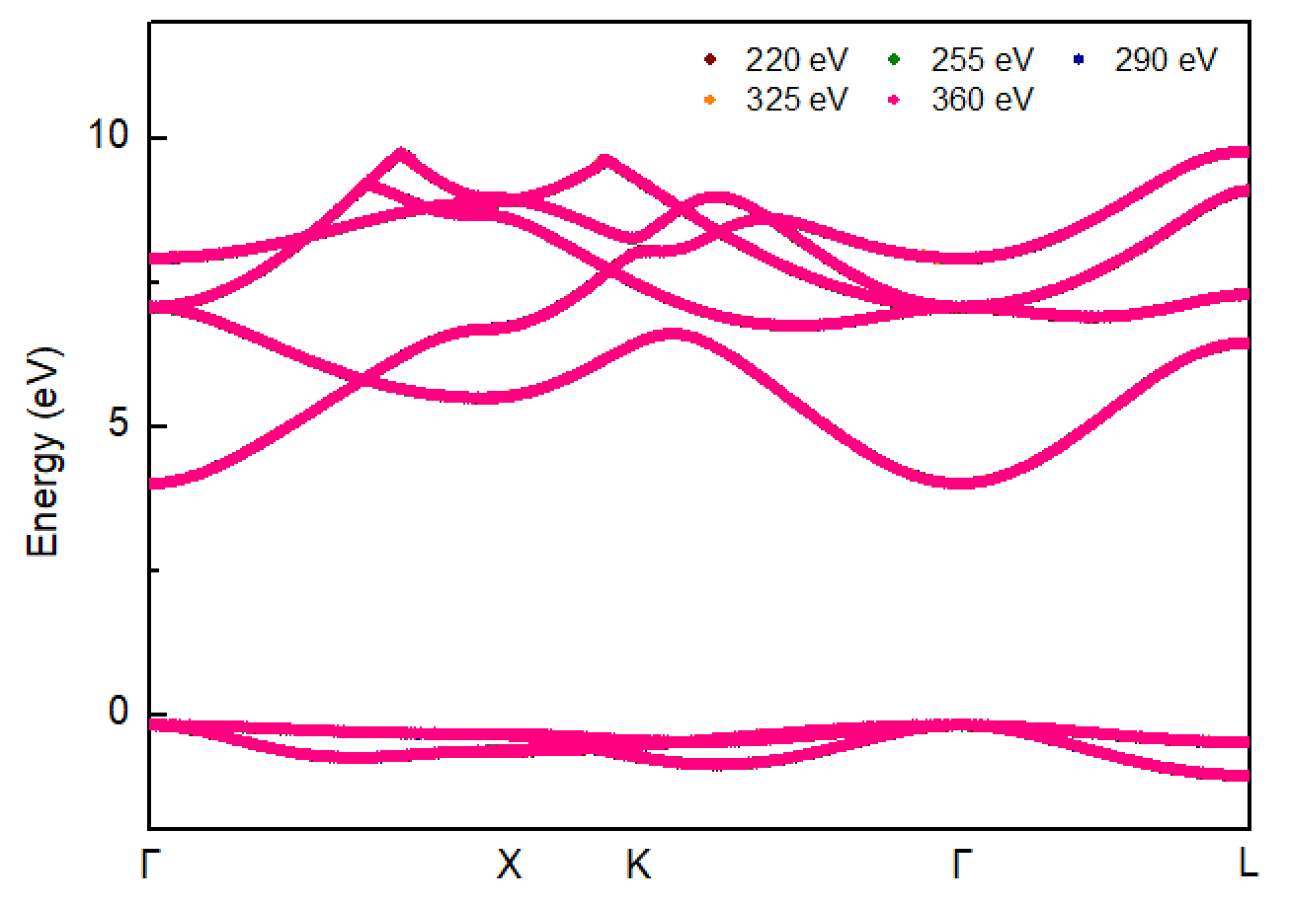

Fig 5. Band structures computed with different ENCUT.

(k-mesh=8x8x8, ISMEAR=0, SIGMA=0.03 eV, EDIFF=1E-9 eV)

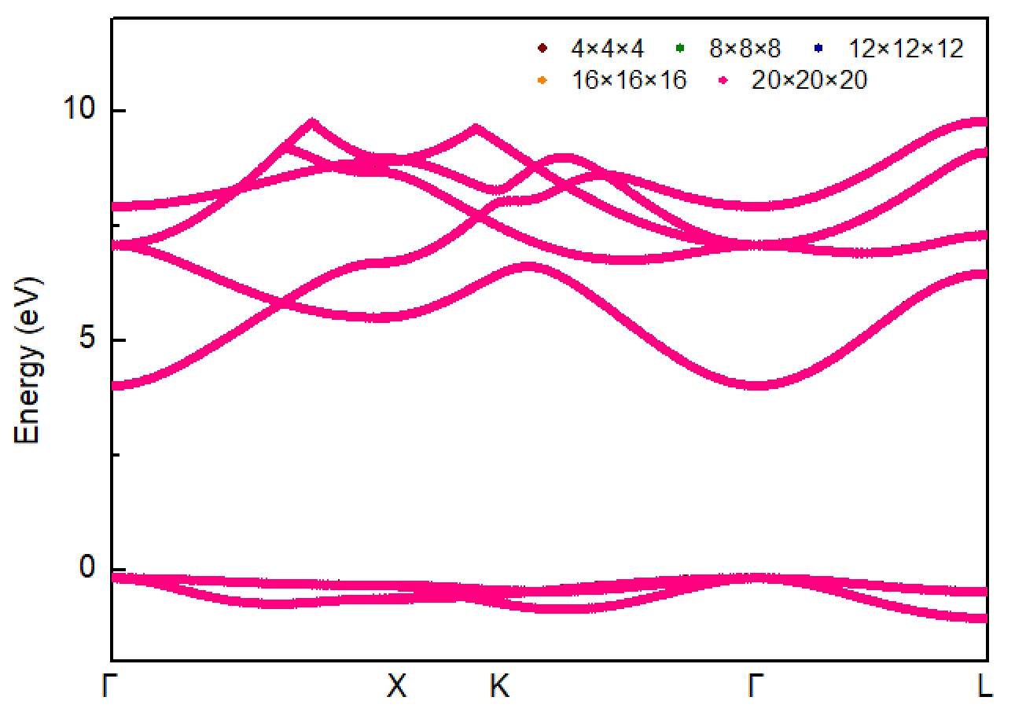

Fig 6. Band structures computed with different k-mesh.

(ENCUT=290 eV, ISMEAR=0, SIGMA=0.03 eV, EDIFF=1E-9 eV)

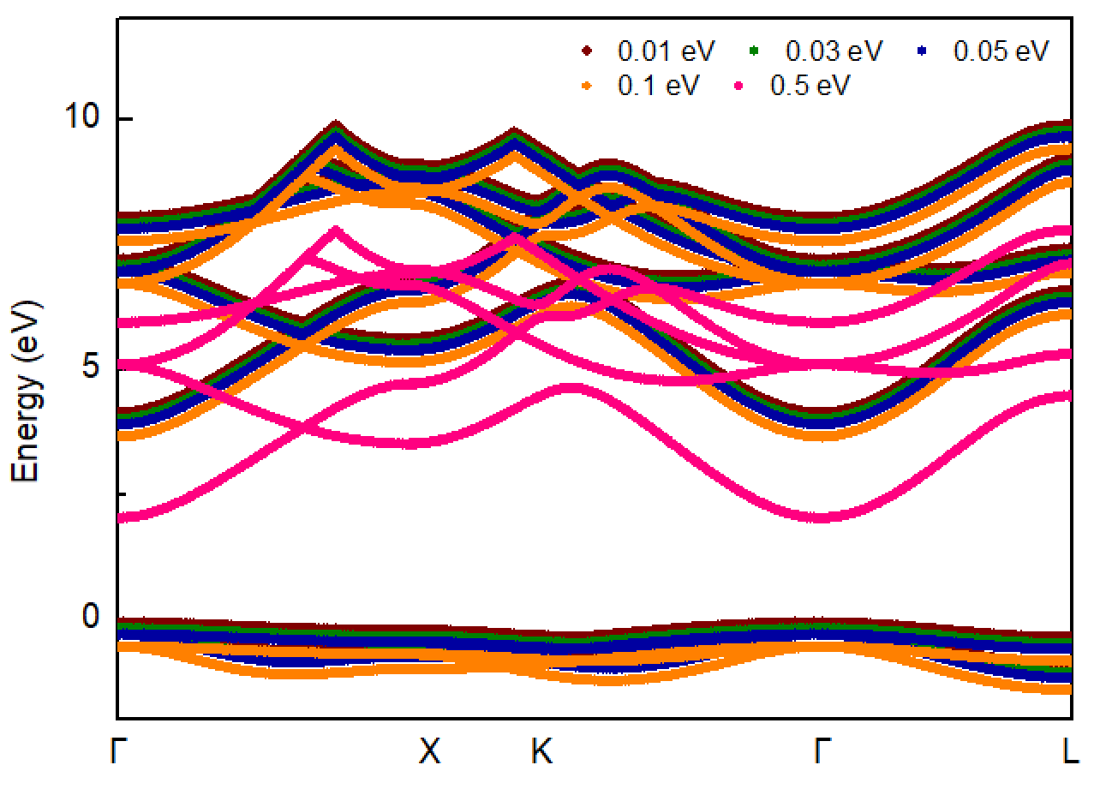

Fig 7. Band structures computed with different SIGMA.

(ENCUT=290 eV, k-mesh=8x8x8, ISMEAR=0, EDIFF=1E-9 eV)

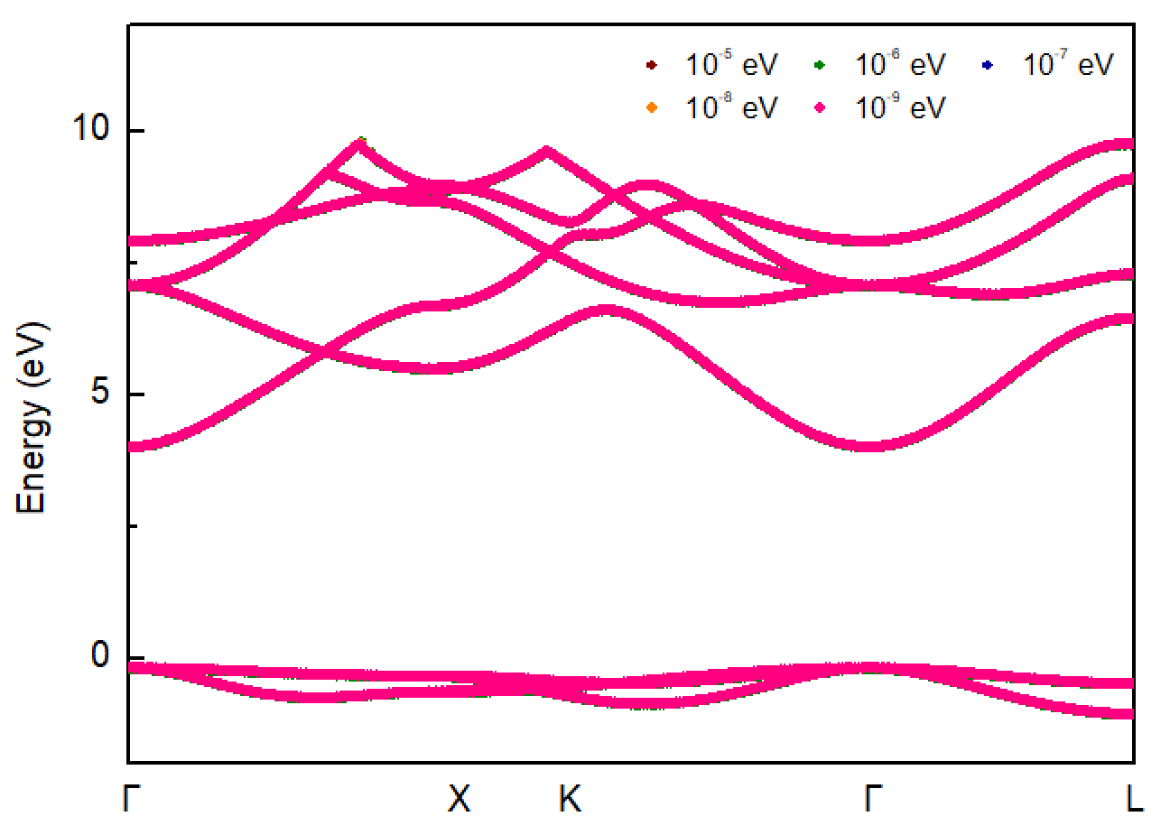

Fig 8. Band structures computed with different EDIFF.

(ENCUT=290 eV, k-mesh=8x8x8, ISMEAR=0, SIGMA=0.03eV)

**Based on the above tests, the band structure was calculated with ENCUT=290eV, k-mesh=8x8x8, ISMEAR=0, SIGMA=0.01eV, and EDIFF=1E-9eV.**

* Other notes / cpu hours

hardware: Intel Xeon Gold 6150, 18 core/CPU, 2 CPUs/node

Cpu hours: 0.080 cores*hours

* All input files to run fully converged calculations

Input files: INCAR.sc, KPOINTS.sc, INCAR.band, KPOINTS.band, POSCAR, POTCAR, run.sh

Location: Team Shiomi/RbBr/Han Meng_VASP/02_Electrons/Input files

***Harmonic***

* Converged dispersion (target accuracy < 0.1 THz for Γ/X/L frequencies)

- Numerical data: normalized wavevectors (q) and frequencies (f) for 6 polarizations (*j*) (excel or text file)

- q in units of 2π/*a* and f in THz (f=ω/2π)

- 3 segments: Γ→X, Γ→K→X, and Γ→L evenly divided with ~100 q points per segment

- 3 files, one for each segment. For each scaled q from 0 to 1 list (~100 rows): q, f1, f2, f3, f4, f5, f6

File name: G-X.txt, G-K-X.txt, G-L.txt

Location: Team Shiomi/RbBr/Han Meng_VASP/03_Harmonic/Results

* Converged harmonic interatomic force constants (IFCs)
* Supercell perturbations or DFPT (provide relevant details)

- Standard format for code used (*e.g.*, QE, Phonopy)

- Will be supplied as supplemental material upon publication

File name: RbBr222_harmonic.xml

Location: Team Shiomi/RbBr/Han Meng_VASP/03_Harmonic/Results

* Long range Coulomb corrections
* Dielectric matrix (1-3x3 matrix)

2.45864145 0.00000000 -0.00000000

0.00000000 2.45864145 -0.00000000

-0.00000000 -0.00000000 2.45864145

* Born effective charge matrices (2-3x3 matrices)

Rb

1.16481147 0.00000000 -0.00000000

0.00000000 1.16481147 -0.00000000

-0.00000000 -0.00000000 1.16481147

Br

-1.16481147 -0.00000000 0.00000000

-0.00000000 -1.16481147 0.00000000

0.00000000 0.00000000 -1.16481147

* Method of long-range Coulomb corrections: Ewald method
* Methods / convergence criteria

- Thresholds: EDIFF=1E-9eV

- Supercell size / integration mesh: 2x2x2 conventional cell, k-mesh=6x6x6

- Symmetries / irreducibility / number of calculations (*linked to cpu hours below*)

Symmetry operations=1536, irreducibility=33 IFCs, number of calculation=2

- Post-processing (*e.g., enforce invariance constraints*)

ALAMODE: ICONST = 1, Constraints for translational invariance is considered

* Evidence of converged dispersion

- Dispersions with varying supercell sizes and integration meshes

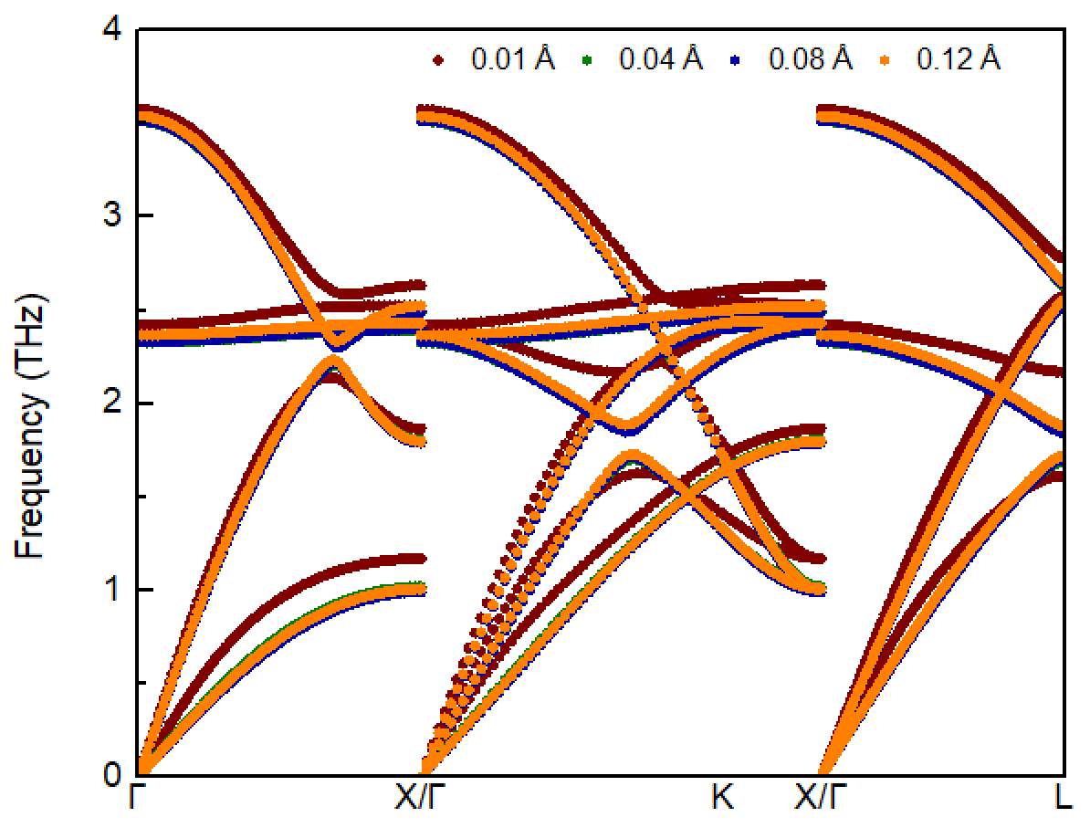

Fig 9. Dispersions computed with different displacements.

(2x2x2 conventional cell, ENCUT=290eV, ISMEAR=0, SIGMA=0.03eV, k-mesh=6x6x6)

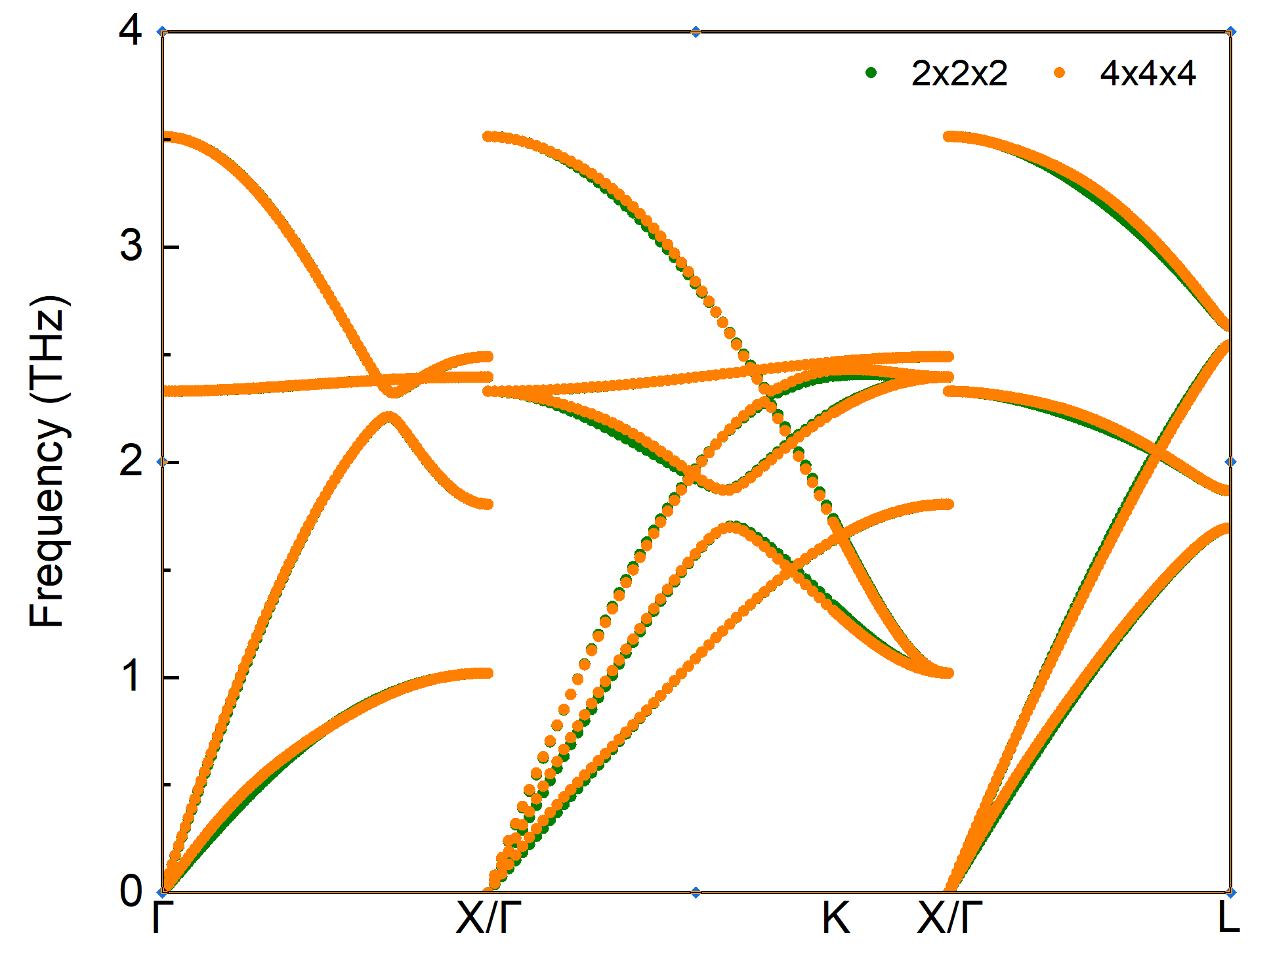

Fig 10. Dispersions computed with different supercells.

(displacement=0.04Å, ENCUT=290eV, ISMEAR=0, SIGMA=0.03eV, k-mesh=6x6x6 as of 2x2x2 conventional cell)

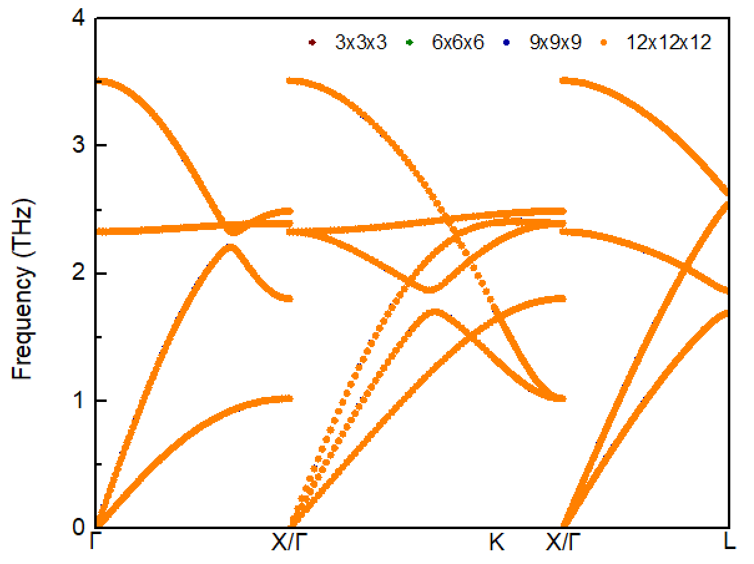

Fig 11. Dispersions computed with different-mesh.

(2x2x2 conventional cell, displacement=0.04Å, ENCUT=290eV, ISMEAR=0, SIGMA=0.03eV)

**Based on the above tests, the phonon dispersion was calculated with displacement=0.04**Å**, 2x2x2 conventional cell, ENCUT=290eV, ISMEAR=0, SIGMA=0.03eV, k-mesh=6x6x6.**

* Other notes / cpu hours (*e.g., accuracy vs cpu cost, shifted meshes*)

hardware: Intel Xeon Gold 6150, 18 core/CPU, 2 CPUs/node

Cpu hours: 29.44 cores*hours

* All input files to run fully converged calculations

Input files: RbBr_alm1.in1, RbBr_alm1.in2, RbBr_band.in, RbBr.born, RbBr222.opt, INCAR, POTCAR, KPOINTS, run.sh

Location: Team Shiomi/RbBr/Han Meng_VASP/03_Harmonic/Input files

***Anharmonic thermal transport***

* Four converged T-dependent thermal conductivities (*k*) (target accuracy <2% difference between successive grids - please contact us if a problem): natural isotopes with full BTE solution (*knat,full*), natural isotopes with the relaxation time approximation (RTA) (*knat,RTA*), isotopically pure (*e.g.*, 100% 85Rb and 100% 79Br) with full BTE solution (*kpure,full*), and isotopically pure with RTA (*kpure,RTA*). If only RTA available, then only *knat,RTA* and *kpure,RTA*

- Do not include boundary scattering, even at low T. We want to see how the codes behave at low T without this extrinsic scattering.

- Numerical data: T (K) and *k* (W/m/K) in range 10K < T < 1000K (excel or text file)

- For 10K ≤ T ≤ 50K increments of 10K (5 data points); for 50K < T ≤ 300K increments of 25K (10 data points); for 300K < T ≤ 1000K increments of 100K (7 data points).

- 1 file with T from 10K to 1000K list (22 rows): T, *knat,full*, *knat,RTA*, *kpure,full*, *kpure,RTA*

- Masses used for pure and natural calculations

File name: TC_temperature.txt

Location: Team Shiomi/Han Meng_VASP/RbBr/04_Anharmonic/Results

* Accumulated T=300K *kacc* vs frequency and *kacc* vs mean free path (mfp) for converged *knat,RTA* value

- Numerical data for each mode (q, *j*) sampled in the Brillouin zone integration: f (THz), mfp=|sqrt(*vx*2+*vy*2+*vz*2)×lifetime| (nm), mode contribution to *k* (W/m/K) for *knat,RTA*

- 1 file (excel or text) with row for each mode (q, *j*): f, mfp, mode contribution to *k*

File name: Accumulated TC_nat_RTA_300K.txt

Location: Team Shiomi/Han Meng_VASP/RbBr/04_Anharmonic/Results

* RTA T=300K three-phonon scattering rates (1/*τ3ph*) and phonon-isotope scattering rates for natural abundance (1/*τiso*)

- Numerical data: f (THz), 1/*τ3ph* (THz=1/ps), and 1/*τiso* (THz)

- 1 file (excel or text) with row for each mode (q, j): f, 1/*τ3ph*, 1/*τiso*

File name: Scattering rate_nat_RTA_300K.txt

Location: Team Shiomi/Han Meng_VASP/RbBr/04_Anharmonic/Results

* Converged third-order anharmonic IFCs

- Standard format for code used

- Will be supplied as supplemental material upon publication

File name: RbBr222_cubic.xml

Location: Team Shiomi/Han Meng_VASP/RbBr/04_Anharmonic/Results

* Methods / convergence criteria: thermal conductivity

- Delta function representation (*with details; e.g., adaptive smearing, cutoff*)

ISMEAR = -1 Tetrahedron method

- Integration grid: q-grid=30x30x30

- Symmetries used: 48 symmetry operations

* Methods / convergence criteria: anharmonic IFCs

- Cutoff radius, supercell size, integration mesh, thresholds, displacement parameter for supercell derivatives

Cutoff=12 Bohr, supercell=2x2x2 conventional cell, k-mesh=6x6x6, EDIFF=1E-9, displacement=0.08Å

- Post-processing

ALAMODE: ICONST = 1, Constraints for translational invariance is considered

* Evidence of converged *k* at T=300K

- Varying integration meshes

- Target accuracy <2% difference between successive grids

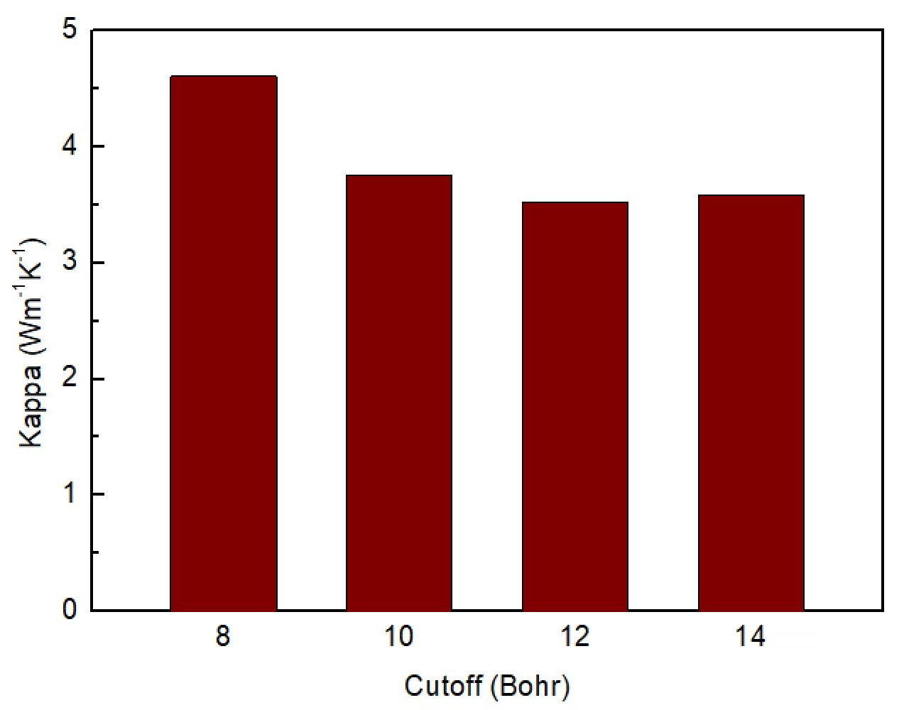

Fig 12. kpure,RTA at 300 K computed with different cutoffs.

(displacement=0.08Å, k-mesh=6x6x6, q-grid=20x20x20)

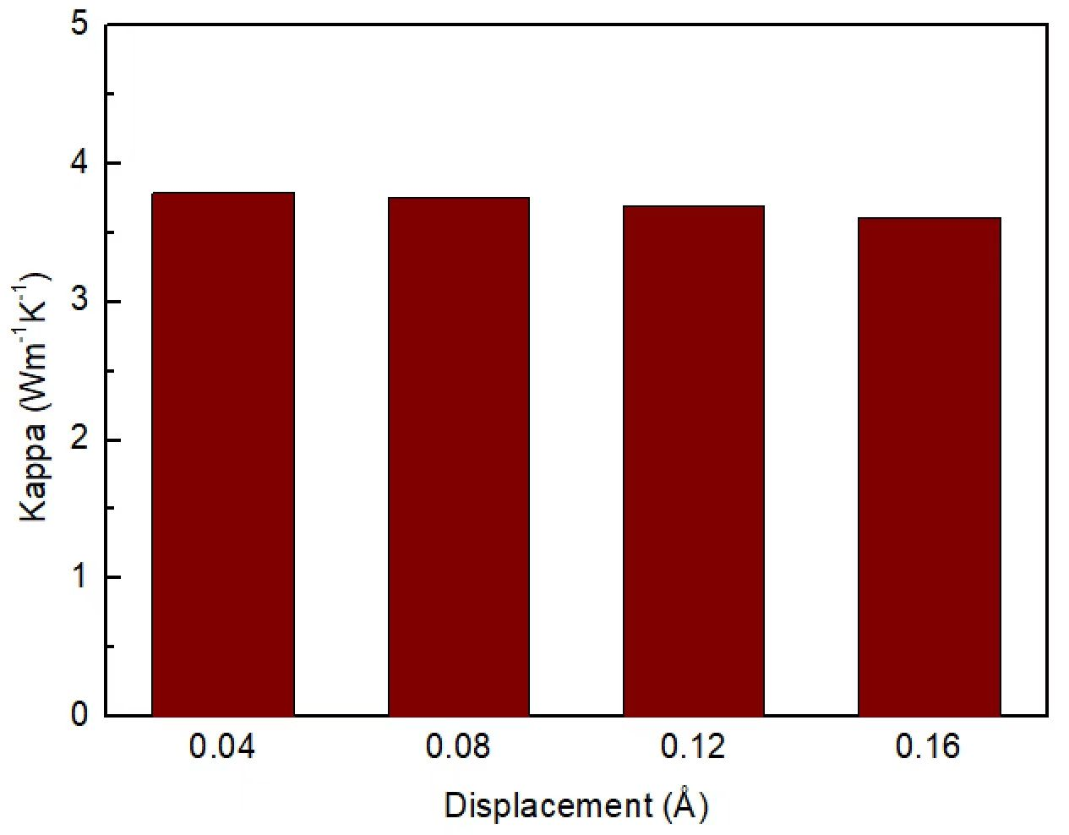

Fig 13. kpure,RTA at 300 K computed with different displacements.

(cutoff=10 Bohr, k-mesh=6x6x6, q-grid=20x20x20)

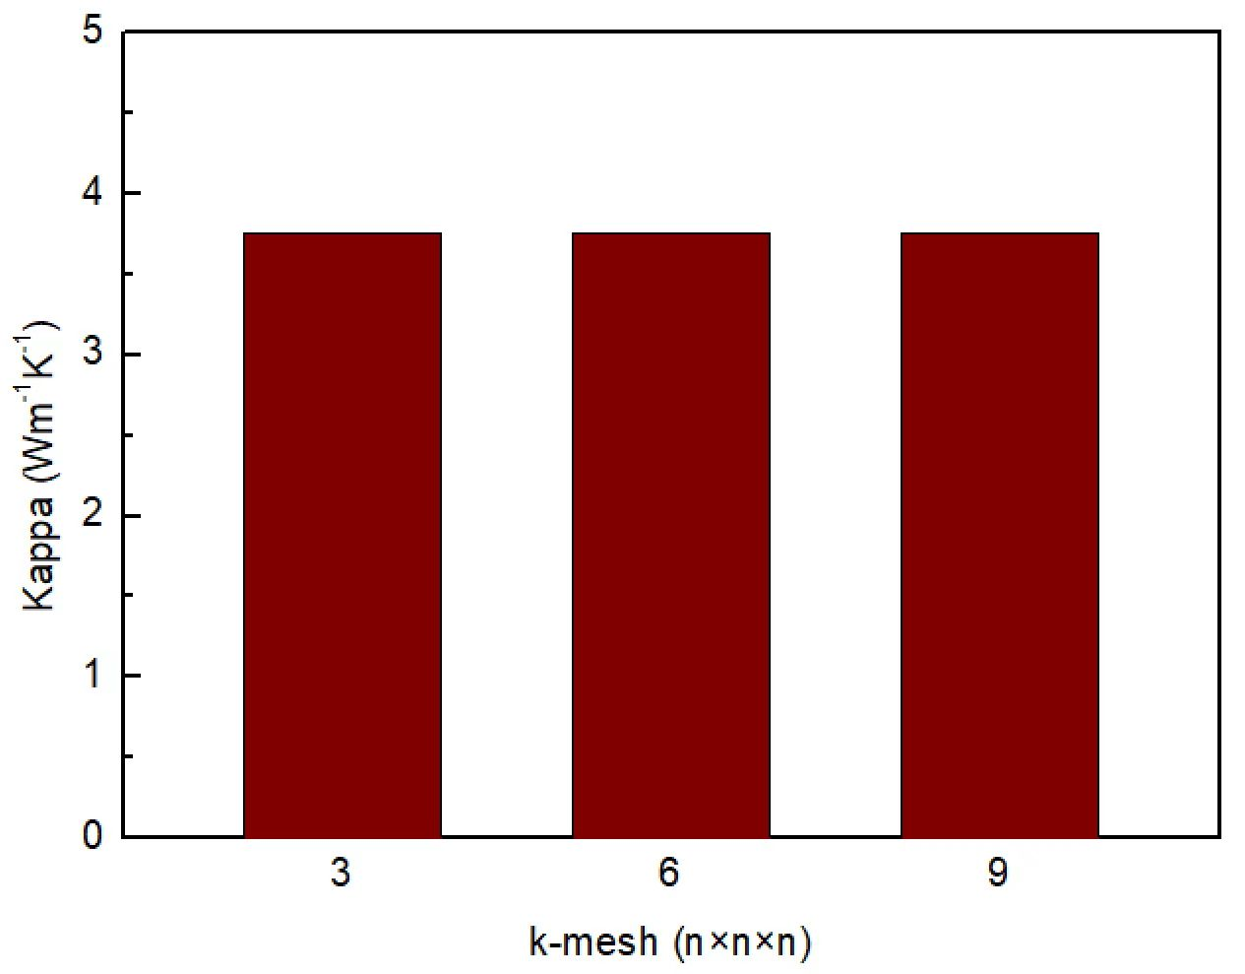

Fig 14. kpure,RTA at 300 K computed with different k-mesh.

(cutoff=10 Bohr, displacement=0.08Å, q-grid=20x20x20)

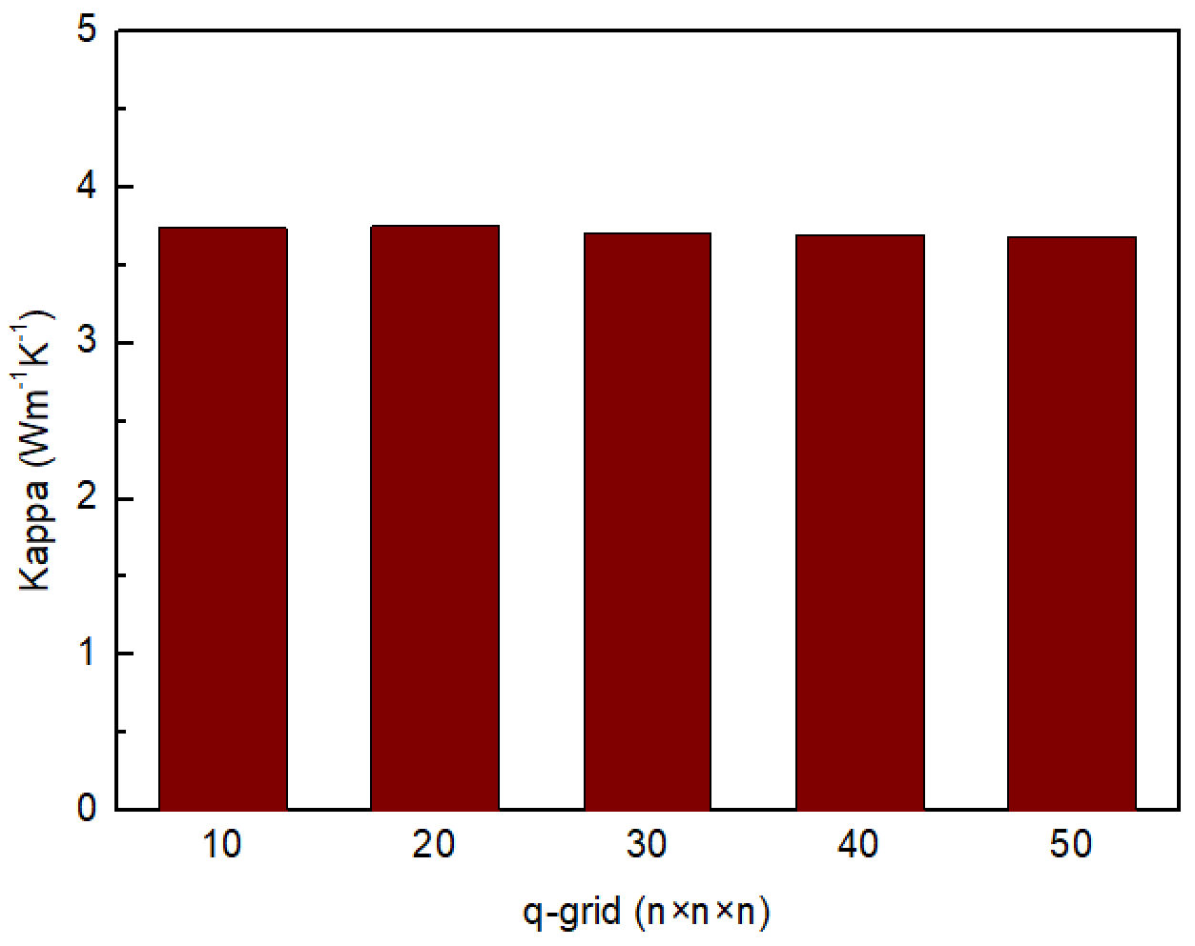

Fig 15. kpure,RTA at 300 K computed with different q-grid.

(cutoff=10 Bohr, displacement=0.08Å, k-mesh=6x6x6)

**Based on the above tests, the thermal conductivity was calculated with 2x2x2 conventional cell, ENCUT=290eV, ISMEAR=0, SIGMA=0.03eV, displacement=0.08Å, k-mesh=6x6x6, q-grid=30x30x30.**

* Other notes / cpu hours

hardware: Intel Xeon Gold 6150, 18 core/CPU, 2 CPUs/node

Cpu hours: 1209.28 cores*hours

* All input files to run fully converged calculations

File name: RbBr_alm2.in1, RbBr_alm2.in2, RbBr222.opt, INCAR, POTCAR, KPOINTS, run1.sh, RbBr_RTA_nat.in1, RbBr_RTA_pure.in1, RbBr.born, run2.sh

Location: Team Shiomi/Han Meng_VASP/RbBr/04_Anharmonic/Input files